**Interaction with virtual game through hand gestures based on computer vision**

Under the Guidance of **DR SWARNALATHA P**

Vellore Institute of Technology

Vellore, India

GOKUL NATH REDDY Y YASWANTH M MD ISMAIL ZABIULLAH

19BCE0210 19BCE0656 19BDS0084 Vellore Institute of Technology Vellore Institute of Technology Vellore Institute of Technology

Vellore, India Vellore, India Vellore, India

**Abstract -** Hand gestures are a simple way for people to communicate, and they may be addressed promptly in human-computer interaction (HCI). This way of user interaction can be used efficiently in the user system interface for a user-friendly interaction. Hand gesture interaction has been the trending era for human computer interaction (HCI). Frequently some of research work are accomplished on this area to expedite and contrive interaction with computers. In this venture, we design a real-time human computer interface system for interaction using two different approaches - hand pointing and clenched fist gesture. This project entails the design and implementation of a HCI the use of webcam or the front cam of laptop. It analyses hand gestures in actual time 2D space of hand using segmentation, thresholding, contouring and convex hulling is used to identify hand gestures.

**Keywords:** real time, path detection, Human Computer Interaction, Palm Recognition, Contour Extraction, Image Preprocessing, OpenCV, tenserflow.

**Introduction:** Hand gesture recognition systems provides an improved interaction experience for the user because it combines a virtual and real-world item. Gesture popularity primarily based totally interactions, offer an extra connection that is both in comparison to normal peripherals, it is more realistic and immersive. The gesture-based interaction interface showcased here are often applied towards many applications like video game, communication techniques and Games. The main focus of our project is on games because the application domain for this interaction method. Gestures, particularly hand gestures are faster and possibly may well be more accurate than using the keyboard–mouse combination of peripherals. The non-touch system might be a cutting-edge form of computer interface technology that reshapes human-computer interaction.

**AIM:** For creating a Human computer interaction video game which we can play with the assist of hand gestures. Gesture recognition primarily based on interactions, offer a greater sensible and immersive interaction in comparison to today’s peripherals.

**SCOPE:** A platform to make a personality's computer interaction game which might be played without using the standard peripherals through hand gestures were the user are going to be able to experience a more real-like and captivating interaction than ever. The game is designed with the notion that anyone with no prior knowledge may play it. Gamers who are having impaired vision are excluded. The users must have their background plain within the webcam view so as detect the object/palm clearly, have their background plain in the webcam view in order detect the object/palm clearly.

**Objectives:** The Primary objective of the game is to provide fun and interesting way of playing a computer game. The game controls are rather more natural and adaptable than the same old keyboard controls. Using hand gestures also promotes physical activity which improves health and general well-being as against traditional keyboard control.

**Literature survey:**

As we studied many research papers from there, we have learned many things such as the new technology trend which is gaining major popularity in the area of non-verbal communication is the interaction of user with system with a non-peripheral interface through gestures. Whenever there is a communication happening between set of people gathered, we most often notice that the gestures play the crucial role in better interaction than the interaction which occurs with the verbal communication alone. This idea of better collaborative communication and interaction can be implied to the systems where users interact on the daily basis for performing various tasks. We have thus used this concept to build an interface which is easy to use by the gamers as the gaming world in modern days is emerging into one of largest growing markets around the globe with more new people developing the interest in this field. After referring to various sources we made analysis and review as an overview on the area of our interest of our project which consists of main key points like:

1) Frame capture for background detection.

2) Extracting the foreground for our image.

3) Records another set of extra frames for the detection of the motion of our object in the foreground.

4) Converting the high-resolution image represented in form of a 3D matrix into a simple less resolution 1D image as lot of data is redundant and saving a lot of computational power as well.

5) Removal of noise done through application of various filtering techniques for easy processing.

6) Thresholding the colors by applying the ranges of pixel for the image distinction.

7) Bordering of the outline of image using the Contouring technique to get rid of redundant inner portions of our image.

8) Dividing the segment of the palm through Segmentation so that we apply the suitable trigonometric formulas to obtain the point of convergence in order to obtain a real-time video sequence.

9)Applying various image processing algorithms for working with the input object.

10)Comparing various methods based on their complexities for the best real-time interface design and usage of various Software libraries and packages for implementation of the specified process in the code format.

**Methodology:** The main domain of the project lies in developing a game with the application of gesture recognition system. The usage of hand gestures to promote virtual activity as one does in real world, results in the main advantage that the game can be played in a virtual space with enhanced interaction much better than conventional peripherals.

**MOTIVATION:** The motivation for the implementation of the project is a concept to build an interface as a goal to provide the gaming world real-time user experience which is easy to use by the gamers as the gaming world in modern days is emerging into one of the largest growing markets around the globe with more new people developing the interest in this field.

**Comparative study:** Existing methods or models currently which are played on laptop majorly uses keyboard and mouse using gestures makes user provides different form of interaction compared to today’s peripherals. Using this type of interaction makes feel like natural and require neither interruption nor an additional device. Furthermore, they do not limit users to single point input, but rather provide various forms of interaction. Make use of peripherals like keyboard, mouse etc. lack the sensitivity desired in required application. Ultimately, researchers in the field of human-computer interaction emphasize the design and development of user interfaces that meet the expected performance standards required in dynamic environments. And the games we have displayed have easier movements to grasp onto and learn. It would take less time to get habituated to them and play efficiently. Palm open and close are the easiest movements one can grasp whereas other methods have very difficult gesture options. We have divided the screen into parts for the user to interact in an efficient way.

**STAKE HOLDERS:**

**User/Customer:** With respect to our project one of the important stakeholders are the players/gamers who come under the description of users who wish to purchase the game.

**Project Member:** Team members who want to showcase their skills in the game development, image processing, python developer and related technical aspects of this project.

**Management team:** they manage the important decision making from the project managers by listening to their opinions before making a decision in order to work as a team in coordination to reach the goal. Therefore, management team plays an important role as a primary stakeholder.

**3rd Party companies:** There might be various problems from the complexities with integration to the inabilities to use the third-party solutions. They also come under the primary stakeholder’s class.

**BLOCK DIAGRAM:**

Here we describe the fundamental processes and how the system works through the interconnection of blocks, where each block depicts the working mechanism of a particular component for the user-game interface design.

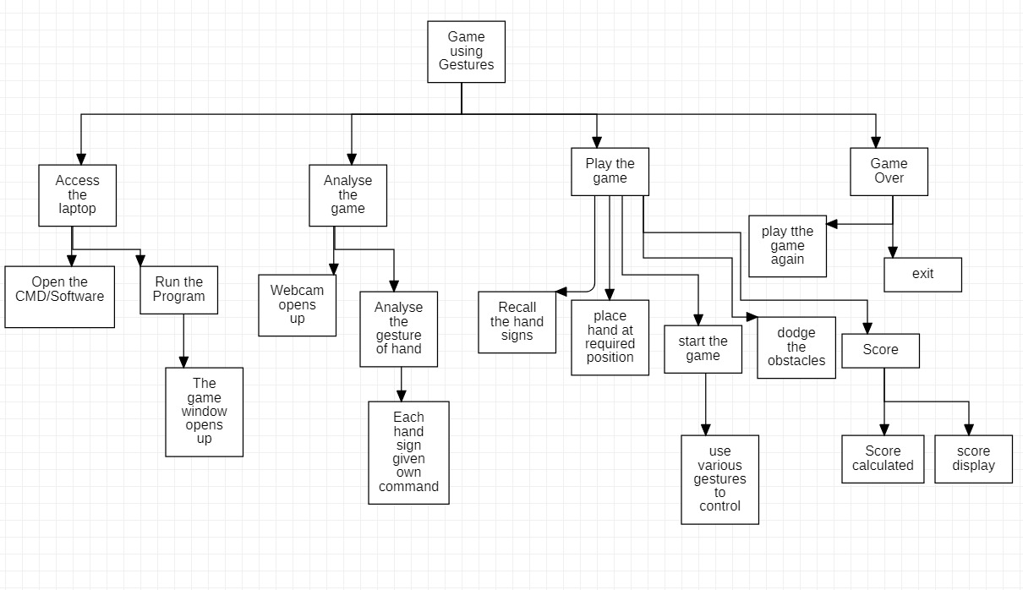

**STATE TRANSITION NETWORK:**

While designing a user interface the designer must help the user easily understand the state of the device based on the actions he takes, as the STN which is not easy to be described by the system directly implies that it is difficult for the user to use it. This indirectly explains how the gesture-based interactions are lesser complex than that of the peripheral controlled interaction.

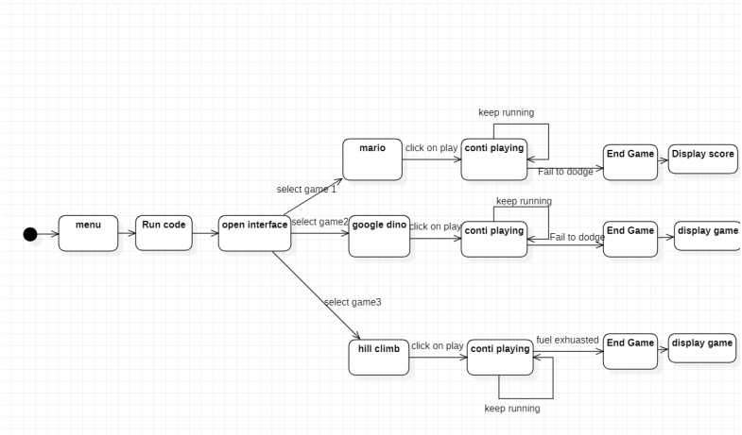

**STORY BOARDING:**

To make the interface more interactive and user-friendly we make use of Storyboarding as this process uses illustrations or images in a sequential manner to illustrate the important steps of the user experience. This process works effectively as the producer and engineer can modify it based on the user needs before actually releasing the product into the market.

1. **Home page:** This is the home page where user can select a specific game.

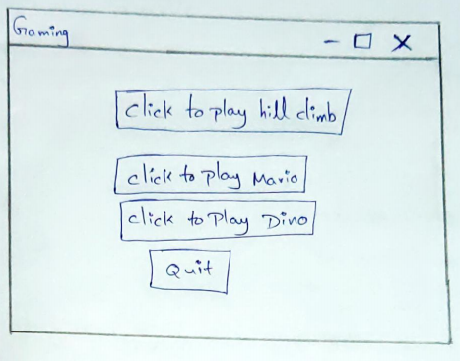

1. **Mario Game approach from user:** Here the user can control the character in the game by giving instructions through hand based on palm-recognition algorithm.

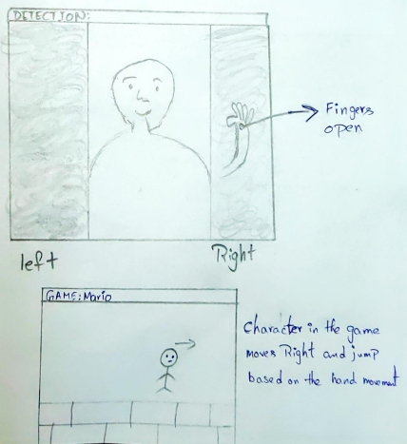

1. **Hill Climbing Game approach from user:** The user may operate the vehicle in game by issuing commands with their hands using a Blue color Detection Algorithm.

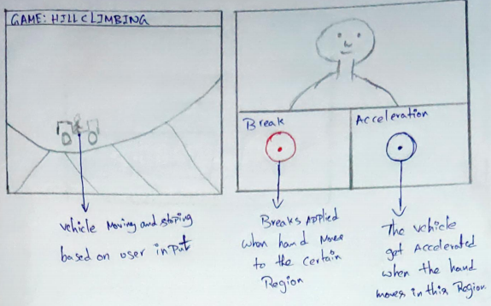

1. **Dino Game approach from user:** As the previous game where the character was controlled by palm-recognition Algorithm here the same approach follows.

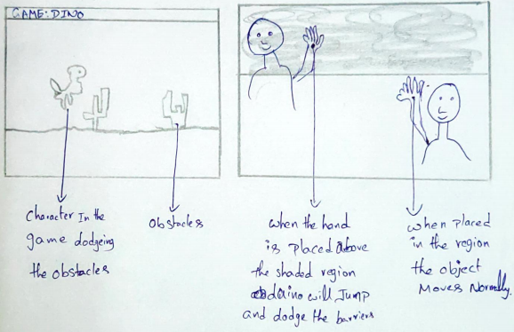

1. **Final Score view to user:** This is a final page where the user gets feedback and various options.

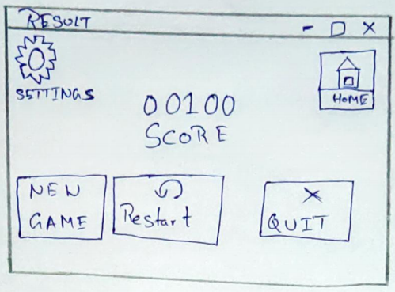

**GOMS MODEL:**

**1.Goals(G):** As a task to play the game using hand gestures.

**2.Operators(O):** As all actions needed to achieve the goal by moving the player swiping either right or left or up and down.

**3.Methods(M):** As a group of operators as we move the hand in appropriate direction these methods can be implemented through various methods like using image processing or machine learning etc.

**4.Selection(S):** As a user decision approach among the various potential methods of implementation we will select the image processing Algorithms like blue color detection and palm recognition.

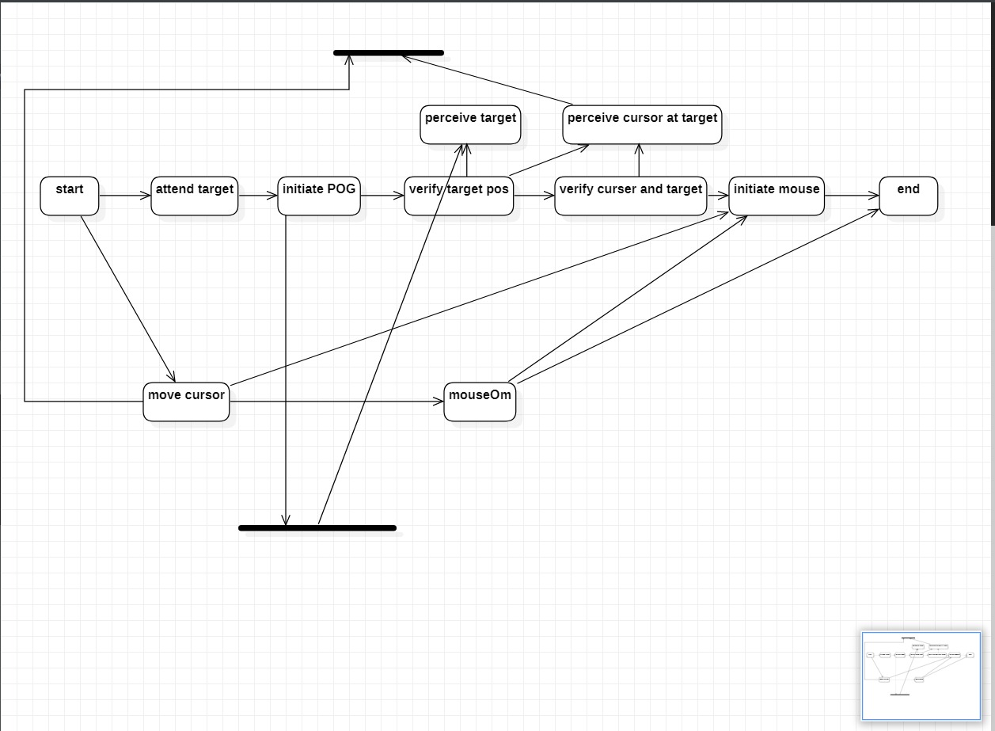

**HTA:** Hierarchical Task Analysis is one of the most effectively way of deciding what tools must the Game developers must use in order to design the games as this approach helps them to either easily modify the existing model with the better alternative solution or when creating a new design in order to achieve required goal.

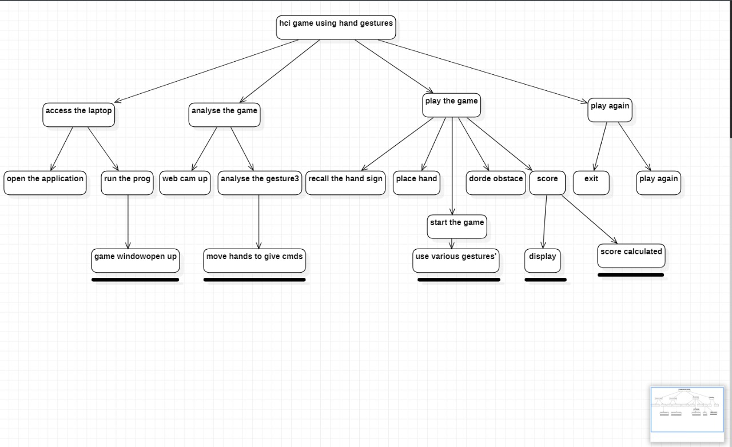

**COMMUNICATION, COLLABORATION and Groupware:**

1.**Simplify the file sharing process:** Anyone may utilize the interface since the file sharing process is simple for those who have been approved by the vendor.

2.**t desking:** Gaming is no longer like grammar school, where user has to sit in a fixed place near the system in a room to play. The gamers can enjoy the experience of gaming sitting anywhere like in lounge areas, couches, and cafeterias etc...

3.**Don’t settle for your current software:** The variety of popular libraries used can be installed by the gamer having no fear of which software they are using.

4.**Reducing inefficiencies in gaming:** a greater number of requirement specifications needed for the game to run might not interest the users because the failure in any of the components may cause inefficiency in user experience hence this project implementation takes care of such possibilities.

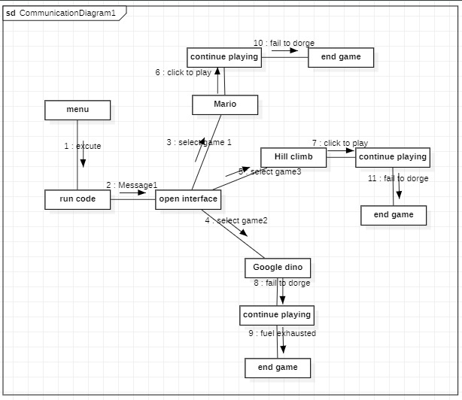

**PROCESS MODEL:**

The game is implemented using well-ordered set of activities to give an abstract description based on the player's needs utilizing specifying, testing, validating, and evaluating the system based on the user needs.

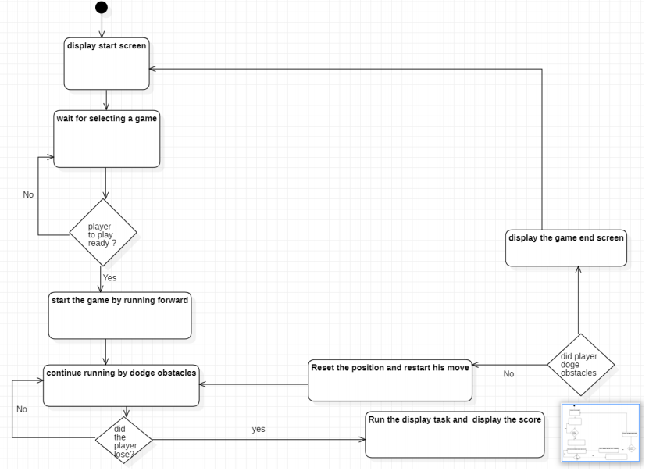

**INTERACTION DESIGN (4 STEPS):** This design helps in improving the interaction experience of the gamers with the product at the time of interaction. It is also used for testing and specification for interface designers and game developers.

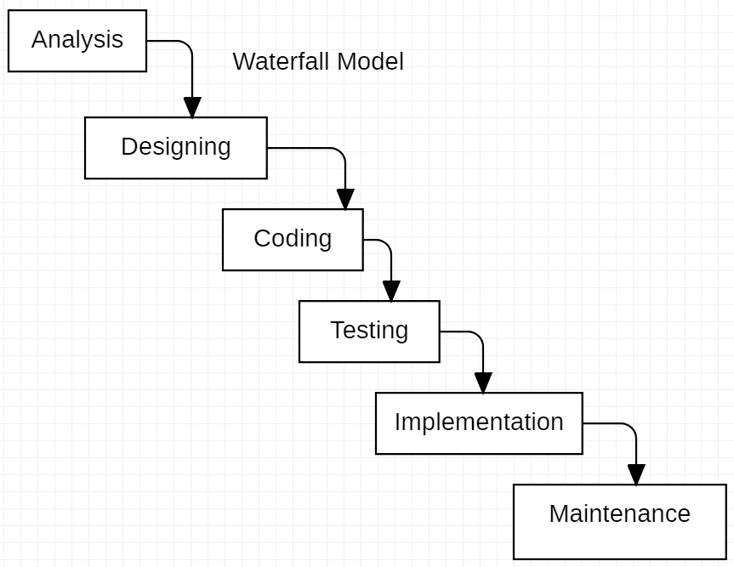

**USE CASE DIAGRAM:** This is how the process where the user interacting to the system interface to play game.

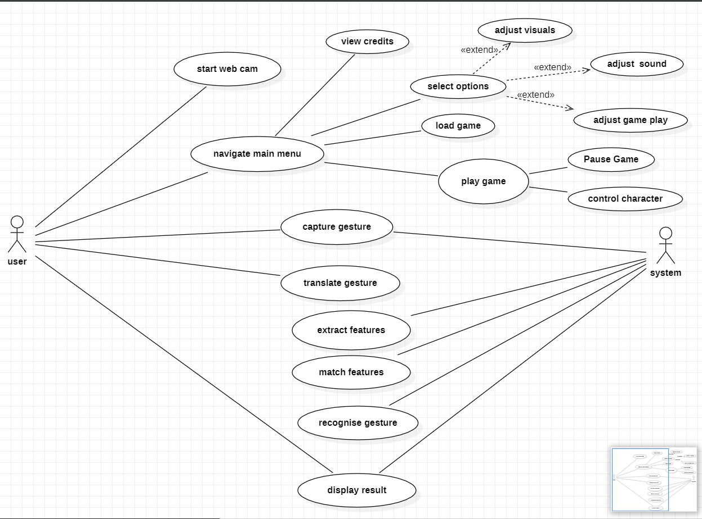

**INTERFACE:** This is the interface we developed which is user friendly and easily accessible.

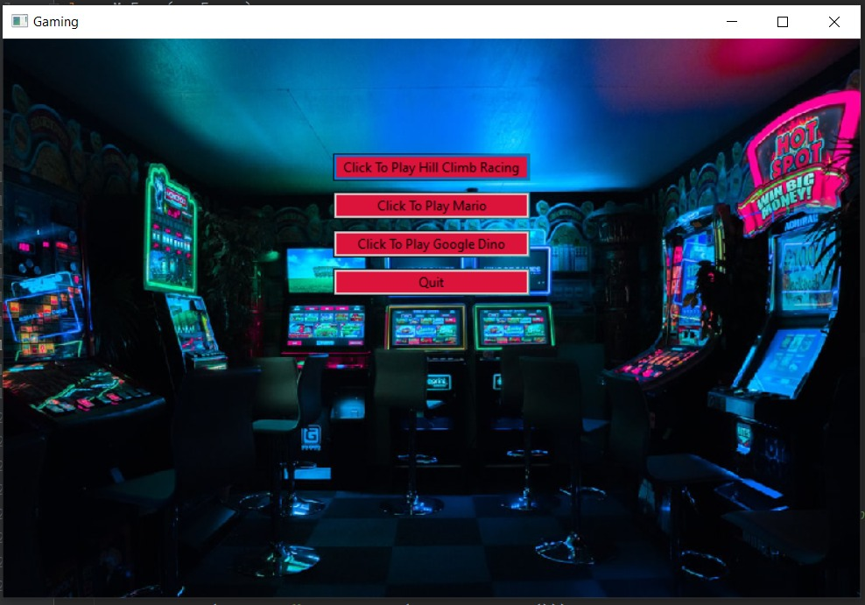

**FUTURE PROSPECTS:**

* Project could be made more dynamic
* More algorithms could be added to the process
* We could even create or build more visualization series
* various algorithm can be implemented

**Results and Discussion:** As we can see from the graph that the more frames used the more trained the system becomes in analyzing the image for the better processing along with various algorithmic analysis done in support to the research for better understanding of computational power, space and time complexities.

X-axis: NO. Of Frames; Y-axis: Image Accuracy

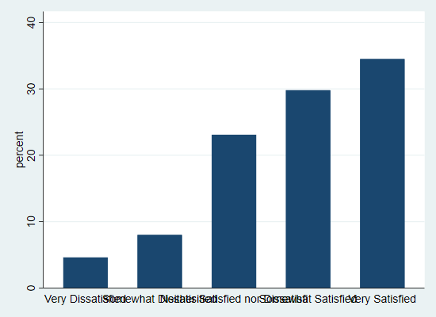

**Conclusion:** Hand Gestures, a nonverbal collaborative communication-inspired system user interface, included various features which would enhance the gamer's interaction experience is a huge upcoming trend because of its future scope. It is going to add huge profits to the gaming sector and generate great revenue as well as it both customer and producer are going to be benefitted. Also, this implementation will reduce the inefficiencies caused by the peripheral gaming mode. This interface was prototyped and developed with the goal of offering a real-time user experience to the world of gaming by following several concepts of HCI: Interactive design, catering to universal usability, KLM, GOMS, interface testing, and usability testing, heuristic evaluation, HTA, Groupware, communication, and collaboration, Use case modeling, State Transition models, storyboarding, offering informative feedback from the users, selecting appropriate methods and algorithms in order to achieve greater efficiency, aesthetic and minimalistic design. The novelty of our project is the hand gesture interaction with various games, which is integrated into our interface as an aim to satisfy the user with a real-time user experience, because the main reason any user must be well aware of the interfacing as more sophisticated designs causes the ineffective interaction which doesn’t satisfy the user which was the main goal in the project as all these features give the gamer's a positive and holistic experience.

**REFERENCES:**

[1] Prajakta Dhamanskar, Aniket C Poojari, Harshita S Sarwade, Renita R D’silva. Human Computer Interaction using Hand Gestures and Voice. 2019 International Conference on Advances in Computing, Communication and Control (ICAC3). IEEE Mumbai, India, 2019.

[2] Siddharth S. Rautaray and Anupam Agrawal. Interaction with Virtual Game through Hand Gesture Recognition. 2011 International Conference on Multimedia, Signal Processing and Communication Technologies. Aligarh, India, 2011.

[3] Ricardo Nakamura, Romero Tori and Joao Luiz Bernardes Jr. Design and Implementation of a Flexible Hand Gesture Command Interface for Games Based on Computer Vision. 2009 VIII Brazilian Symposium on Games and Digital Entertainment. Rio de Janeiro, Brazil, 2009.

[4] Yanmin Zhu, Zhibo Yang, Bo Yuan. Vision Based Hand Gesture Recognition. 2013 International Conference on Service Sciences (ICSS). Shenzhen, China, 2013.

[5] K. K. Biswas, Saurav Kumar Basu. Gesture recognition using Microsoft Kinect®. The 5th International Conference on Automation, Robotics and Applications. Wellington, New Zealand, 2011